VIETNAM NATIONAL UNIVERSITY OF HOCHIMINH CITY

THE INTERNATIONAL UNIVERSITY

SCHOOL OF COMPUTER SCIENCE AND ENGINEERING



SIMPLE CHATBOT USING SENTIMENT ANALYSIS

By

Nguyễn Quốc Sơn

Ho Chi Minh City, Vietnam  
2019

# TABLE OF CONTENTS

TABLE OF CONTENTS i

LIST OF FIGURES ii

ABBREVIATIONS iii

ABSTRACT iv

CHAPTER 1 1

INTRODUCTION 1

1.1. Background 1

1.2. Problem Statement 7

1.3. Scope and Objectives 7

CHAPTER 2 7

LITERATURE REVIEW/RELATED WORK 7

2.1. VietTreeBank 8

2.2. VLSP 2018 10

2.3. UIT-VSFC 12

CHAPTER 3 17

IMPLEMENTATION 17

3.1. Choosing CNN or RNN 17

3.2. Choosing NLP tools 20

3.3. Dataset 20

CHAPTER 4 21

EXPERIMENTS AND RESULTS 21

4.1. Load the dataset 21

4.2. Word segment 23

4.3. Vector value of each word in each review 24

4.4. Bulding train and test batch 24

4.5. Bulding RNN model with tensorflow 25

4.6. Create input and output 26

4.7. Training the system 26

4.8. Test the model 28

4.9. Results 28

CHAPTER 5 30

CONCLUSION AND FUTURE WORK 30

5.1. Conclusion 30

5.2. Future work 32

REFERENCES 33

# 

# LIST OF FIGURES

Figure 1: Overview of NLP ...........................................................................................................3

Figure 2: CBOW ............................................................................................................................6

Figure 3: Skip-gram .......................................................................................................................6

Figure 4: CNN-based frameworks to NLP tasks............................................................................17

Figure 5: CNN-based frameworks example...................................................................................18

Figure 6: Recurrent Neural Network framework..........................................................................19

Figure 7: Input/ Output of Sentiment Analysis ..............................................................................21

Figure 8:Input/ Output in terms of Word Embedding ....................................................................21

Figure 9: Architecture ....................................................................................................................23

# ABBREVIATIONS

NLP: Natural language processing

POS: Part – Of – Speech

SVM: Support vector Machine

# ABSTRACT

Students’ feedback is both a powerful source for improvement of education quality and an important resource for research on sentiment analysis and education. With the development of the Internet and technology, different types of social media such as social networks and forums have allowed students to not only share informations but also to express their opinions, attitudes on services and other issues regarding education. Among the sources, social media is a great place to get students opinion on school in various areas. By categorising the opinions on this platform, it is expected that we can improve the school quality, which is also helpful for research on education, especially in Vietnam.

The development of tools to improve the education quality is completely essential and beneficial for a range of institutes or universities. Yet, to this day, there exists no tool that could categorize student’s opinions, either qualitatively or quantitatively, in an automated manner. There have been some scholarly works that deal with labelling the reviews using sentimental analysis, e.g…. However, the researches did not mention any possibility on automating such system by developing a chatbot. In the practical world, not many universities have readily-available chatbot for this purpose as well. More specifically, at International University, Vietnam, the university administers an official Facebook page where students could express their ideas, opinions, or any ideas that they would like to share with others and with the school about their studies or education in general. The fanpage is quite active with … interactions/comments per post on average, which means that the amount of student opinion data is enormous. It is hoped that, by applying a chatbot to this platform, student’s opinions will be better categorized and the information and feedback between the students and the schools could be faster and more efficient.

With the primary goal of developing a chatbot for International University, Vietnam fanpage, this thesis first investigated the available literature on the subject of sentimental analysis, then built the prototype using Python language. The prototype was then tested with data (i.e. student’s existing opinions) retrieved from the “IU Confessions” Facebook page. This project was carried out by 1 author, Quoc Son Nguyen during xxx months from … to ….

The final version of the chatbot was chosen based on the level of accuracy and speed of sentimental analysis. In this version, each time an analysis is run, the results are given within less than a miute, at accuracy level of 9..%.

# CHAPTER 1

# INTRODUCTION

## Background

* Introduction to Machine Learning

A computer program is said to learn from experience E with respect to some tasks T and performance measure P. If its performance at tasks in T, as being measured by P, improves with experience E[1]

a. **Tasks, T**

The tasks in Machine Learning usually describes how Machine Learning processes the data point. In image classification, the data point is one pixel in the image. In customer classification, the data point is the customer. In the spam email classification, the data point is the email. The data point includes different features. Each feature is described by number. Therefore, the data point is described by the vector x ∈ Rd, in which d: the number of features in the data point[1]

**b**. **Performance measure, P**

In order to check the competence of the machine learning algorithm, the performance measurement need to be designed to measure the competence.

When Machine Learning algorithms are implemented, the datasets is separated into two parts: training set and test set. The training set is used to find out the parameters of model. The test set is used to measure the competence of model

In current models, the difference between training set and test set is slightly ambiguous. The parameters of Machine Learning algorithms are always updated based on the new data points, these algorithms are called Online Learning. In the beginning, these new data points are not used by the models, but after that, the models use these data points to improve the parameters.[1]

**c. Experience, E**

Training the Machine Learning model on the subset of dataset can be considered as experience of model on training set, so the quality of training set affects substantially on the parameters of the model

Based on the properties of dataset, Machine Learning algorithms can be classified into two groups: supervised learning and unsupervised learning[1]

**d. Supervised learning and Unsupervised learning**

* Supervised learning

o Supervised Learning is algorithms predicting the labels of the data points based on the data points training set [2]

o Supervised Learning solves problem when dataset has the input

$X=\{x_{1},x_{2},…,x_{N}\}$ and output $Y=\{y_{1,}y_{2},… ,y_{N}\}$, in which , xiy i is the vector.

Based on the dataset, the function is built to map the x**i** to y**i** : , [3]

* Unsupervised Learning:

In supervised learning, the output $Y=\{y_{1,}y_{2},… ,y_{N}\}$, is unknown. The model is only built based on the input $X=\{x_{1}, x_{2}, …, x_{N}\}$ which is the features of data points. Based on the structure of dataset, the unsupervised learning will build the model, for example, clustering or dimensionality reduction[4]

In the probabilistic view, unsupervised learning experiences the data points x to learn the probability distribution p(x). While the supervised learning experiences the input x and output y to optimize the conditional probability p(y|x)

* Semi-supervised Learning:

The dataset, the model base on to build, includes the labeled and unlabeled data points. This type of learning occurs very frequently in the Internet when the small part of image or text is labelled, the other large part retrieving from the Internet is unlabeled. Many problems of Machine Learning today are fell into this kind of learning because collecting the labeled dataset is a time- and money-consuming process. In addition, some datasets are too hard to classify, for example, medical images[5]

* Reinforcement Learning:

Reinforcement Learning does not need dataset to train. It experiences explicitly the environment, continuously receives feedback from the environment to improve. Automatic driving car is the most popular application. Currently, reinforcement learning is applied into games that the computer can simulate the environment[6]

d. Cost function and parameters

Model parameters are very important in each Machine Learning model. The training process is to determine the most appropriate model parameters. Quantitatively, the best model parameters will make the best result in performance measurement. In the classification problem, the better result in performance measurement, the fewer points are misclassified. In the regression problem, the better result in performance measurement, the less deviation between the predicted and target values

The correlation between performance measure and model parameters is described by cost function. The less cost function is, the better the model parameters are. Therefore, the training process in machine learning is the optimization process

Θ: model parameters, L(θ): cost function of the model. Machine Learning models can be written by: Θ = arg Θ minL (Θ). Machine Learning model determines the Θ such that L(θ) is minimum[7]

1. **Natural Language Processing**

Natural Language Processing, or NLP for short, is an automatically way to understand and process the information from natural language by human such as text or speech by software[8]

**[ Problem with NLP:**

“It is hard from the standpoint of the child, who must spend many years acquiring

a language ... it is hard for the adult language learner, it is hard for the scientist

who attempts to model the relevant phenomena, and it is hard for the engineer who

attempts to build systems that deal with natural language input or output. These

tasks are so hard that Turing could rightly make uent conversation in natural

language the centerpiece of his test for intelligence.” (Page 248, Mathematical Linguistics, 2010.) ]

There are substantial problems which are solved by Machine Learning. Below is the most popular problems Machine Learning can solve:

* + Classification

o In the problem, the requirement is predicting the label of the data point. The labels are usually numbered from 1 to C. To solve the problem, the function: $f:R^{d} →\{1,2,…,C\}$ should be figured out. The problem of handwritten digit recognition MNIST is the most basic and popular classification

o In some current state-of-the-art models, the output of classification problem is the vector y ∈ Rc in which yc is the probability of data point x has the label of c. Therefore, the label has the largest probability is the label for data point x.

Applying the probability in Machine Learning is very vital because it demonstrates the confidence of model. In particular, if the largest probability is considerable when compared to the second largest probability, it can be said that the model is high confidence in classification of data point x. On the contrary, if the difference between the largest and the second largest probability is small, it’s likely to misclassify [9]

* + Regression

o In the problem, output of model is the real value instead of the label. The function: $:R^{d} →R$ . For example, estimating the price of the house which has the area of x (m2), y bedrooms and the distance from downtown is z (km).

o In the advanced regression problems, the output of the model is multiple real values, so the function in this case is : $f:R^{d} →R^{m}$. Take the a single image with super resolution as example, the model in this problem make the higher resolution image based on the lower resolution image

* + Clustering:

Clustering will classify the unlabeled datasets X into subsets based on the correlation among the data points in one subset. For instance, clustering the customers based on their buying behavior. This application is very popular and assists a lot in recommender systems.

* + Completion:

Completion is the problem of filling the missing data points. In the real datasets, collecting all information is almost infeasible. For example, collecting all ratings of all users on all items in the recommender system is too difficult because most of users does not explicitly rate the items on the website. Therefore, the completion will fill the missing data points based on the correlations among the data points.

**Python:** Python is an general-purpose programming language created by Guido van Rossum. The main design philosophy of Python is to create more easily read program language by useterlize whitespace. It goal is to help programmer to write more logical code while still remain clear and is applyable for both small and large-scale projects.[10]

In 2000, Python 2.0 was released with many features like list comprehensions and a garbage collection system capable of collecting reference cycles.

In 2008 Python 3.0 was released, which was a major revision from the previous version. Unfortunally, it was not backward-compatible, and so, many of the library for Python 2 cannot be use for Python 3. Due to concern about the amount of code written for Python 2, support for Python 2.7 (the last release in the 2.x series) was extended to 2020 [11]  
[Language developer Guido van Rossum shouldered sole responsibility for the project until July 2018 but now shares his leadership as a member of a five-person steering council][11]  
Python flask:

**[ Flask** is a micro web framework written in Python. It is classified as a microframework because it does not require particular tools or libraries.[3] It has no database abstraction layer, form validation, or any other components where pre-existing third-party libraries provide common functions. However, Flask supports extensions that can add application features as if they were implemented in Flask itself. Extensions exist for object-relational mappers, form validation, upload handling, various open authentication technologies and several common framework related tools. Extensions are updated far more regularly than the core Flask program.][12]  
Websocket:

[Unlike HTTP, WebSocket provides full-duplex communication. Additionally, WebSocket enables streams of messages on top of TCP. TCP alone deals with streams of bytes with no inherent concept of a message. Before WebSocket, port 80 full-duplex communication was attainable using Comet channels; however, Comet implementation is nontrivial, and due to the TCP handshake and HTTP header overhead, it is inefficient for small messages. The WebSocket protocol aims to solve these problems without compromising security assumptions of the web.][13]

## Problem Statement

With the goal of creating a chatbot, the problems come from the language itself. Vietnamese is an isolating language. There is no word delimiter in Vietnamese. The smallest unit in the construction of words is syllable. Words can be single or compound. Vietnamese script is invented based on Latin alphabet in which the expansion includes accent characters and stressed accents

When dealing NLP, especially in Vietnamese, the first problem is word segmentation. The definition of word segmentation is the problem of dividing a string of written language into its component words that have the right meaning in an sentene. While in English, a single word is indicated by the white space, it is not the case for Vietnamese. White space when written in Vietnamese is also used to separate syllables that constitute words. So for Vietnamese NLP, word segmentation is referred to as the key first step (Dien et al., 2001). The example in [14]: The annotators would need to identify these combinations as words in meaning A column and not words in meaning B.

|  |  |  |
| --- | --- | --- |
| **Word** | **Meaning A** | **Meaning B** |
| nhà cửa | Nhà cửa bề bộn quá | Ở nhà cửa ngõ chẳng đóng gì cả |
| sắc đẹp | Cô ấy giữ gìn sắc đẹp | Bức này màu sắc đẹp hơn |
| hiệu sách | Ngoài hiệu sách có bán cuốn này | Ngoài cửa hiệu sách báo bày la liệt |

Table 0.1.Example of Words segmentation

After word segmentation, next problem would be POS tagging. POS tagging is one of the most fundamental natural language processing (NLP) tasks. POS tagging is an important first step towards many other NLP tasks. For example, with the sentence “thuế thu nhập cá nhân”, the word segmenter returns a two-word phrase “thuế_thu_nhập cá_nhân.”. Then given the input segmented text “thuế_thu_nhập cá_nhân”, the POS tagger returns “thuế_thu_nhập/N cá_nhân/N.”

The final problem with a chatbot for a school is sentiment analysis in the education domain. Even though there have been some projects about Vietnamese sentiment analysis, but there are not many about education domain specifically. So there are still a lot to explore in this area.

## Scope and Objectives

The goal is to do sentiment analysis on student’s vietnamese comment to categorise it in either “question” or “comment”, if it a comment, categorise it in either “positive” or “negative” to get the right response. If it a question, search from the database of answer using the key words in the question to get the response. Therefore, creating a simple chatbot to response to any messasge.

## Assumption and Solution

Abc…

## Structure of thesis

# CHAPTER 2

# LITERATURE REVIEW/RELATED WORK

2.1 Overview

In the early days of research, researchers focus on identifying sentiment mainly on news text [14], [15], [16], [17]. In recent years, there have been many the well-known shared tasks about opinion mining on Twitter, for examples, the SemEval-2013 Task 2 [18], and SemEval-2014 Task 9 (Rosenthal et al., 2014) did experiments on two sub-tasks consisting of a expression-level and a message-level polarity; and the SemEval-2015 Task 10 [19] added subtasks on topic-based message polarity classification. The SemEval-2016 Task 4 [20] dropped the phrase-level subtask and the strength of association subtask, and focused on sentiment with respect to a topic. In addition, there were several related work on opinion mining in e-learning data [21], [22], [23], [24]. In term of Vietnamese language, it also has few resources for research on natural language processing. However, there are merely a few of research works on opinion mining, for examples, computer customers’ reviews (laptops and desktops) [14], hotel reviews [15], electronic devices [16]. As can be seen that these works are primarily focused on e-commerce products, additionally there have been only few sentiment experiments related to education domain as students’ feedback data [20]. Students’ feedback can help the lecturers and the education managers understand learners’ behaviors as well as learning and teaching activities which learners desire.

* 2.2 Word Embedding

Word embeddings is the process of making words with similar meaning are represent in similar ways. They are a distributed representation for text that is perhaps one of the key breakthroughs for the impressive performance of deep learning methods on challenging natural language processing problems. [1]

Word2vec was created by a team of researchers led by Tomas Mikolov Tomas and patented[16] and it aim is to solve the problem of word embedding. Word2Vec is a kind of model that are use to do word embeddings tasks. As the name implies, the model is job is to convert a word into vectors space, typically of several hundred dimension, with each unique word in the corpus being assigned a corresponding vector in the space.The vectors of a single word are positioned in the vector space such that words that share common contexts in the corpus are located in close proximity to one another in the space.. The model contain two-layer neural networks that are trained to reconstruct linguistic contexts of words.[16]

Around 2013, Mikolav proposed both the CBOW and skip-gram models. CBOW is a neural approach to construct word embeddings and the objective is to compute the conditional probability of a target word given the context words in a given window size. On the other hand, Skip-gram is a neural approach to construct word embeddings, where the goal is to predict the surrounding context words (i.e., conditional probability) given a central target word. For both models, the word embedding dimension is determined by computing (in an unsupervised manner) the accuracy of the prediction.[15]

* One of the challenges with word embedding methods is when we want to obtain vector representations for phrases such as “hot potato” or “Boston Globe”. We can’t just simply combine the individual word vector representations since these phrases don’t represent the combination of meaning of the individual words. And it gets even more complicated when longer phrases and sentences are considered.
* The other limitation with the word2vec models is that the use of smaller window sizes produce similar embeddings for contrasting words such as “good” and “bad”, which is not desirable especially for tasks where this differentiation is important such as sentiment analysis. Another caveat of word embeddings is that they are dependent on the application in which they are used. Re-training task specific embeddings for every new task is an explored option but this is usually computationally expensive and can be more efficiently addressed using negative sampling. Word2vec models also suffer from other problems such as not taking into account polysemy and other biases that may surface from the training data.

Word Embedding are the algorithm to convert texts into. Many Machine Learning algorithms require numbers as inputs. The different types of word embedding can be classified into two categories: Frequency based Embedding and Prediction based Embedding

* In Frequency based Embedding, there are two types: Count Vector and TF-IDF[16]

o Count Vector: Consider a Corpus C of D documents {d1,d2…..dD} and N unique tokens extracted out of the corpus C. The N tokens will form our dictionary and the Count Vector matrix . Each row in the matrix M contains the frequency of tokens in document D(i).

For example: `1

D1: He is a lazy boy. She is also lazy

D2: Dick is a lazy person

The 2 x 6 matrix:

|  |  |  |  |  |  |  |
| --- | --- | --- | --- | --- | --- | --- |
|  | He | She | Lazy | Boy | John | Person |
| D1 | 1 | 1 | 2 | 1 | 0 | 0 |
| D2 | 0 | 0 | 1 | 0 | 1 | 1 |

In practice, the matrix can be very sparse and inefficient for computation

* Vector for ‘lazy’: (2, 1)

o Term Frequency – Inverse Document Frequency (TF-IDF): Common words like ‘is’, ‘the’, ‘a’ etc… tend to appear quite frequently in comparison to the words which describe the content of a document. TF-IDF penalizes the common words by assigning them lower weights while giving more weight to main words in a particular document. For example:

Document 1: The game of life is a game of everlasting learning

Document 2: The unexamined life is not worth living

Document 3: Never stop the learning

Step 1: Term Frequency: measures the number of times word occurs in a document

TF for Document 1

|  |  |  |  |  |  |  |  |  |
| --- | --- | --- | --- | --- | --- | --- | --- | --- |
| Document1 | the | game | of | life | is | a | everlasting | learning |
| Term Frequency | 1 | 2 | 2 | 1 | 1 | 1 | 1 | 1 |

TF for Document 2

|  |  |  |  |  |  |  |  |
| --- | --- | --- | --- | --- | --- | --- | --- |
| Document2 | the | unexamined | life | is | not | worth | living |
| Term Frequency | 1 | 1 | 1 | 1 | 1 | 1 | 1 |

TF for Document 3

|  |  |  |  |  |
| --- | --- | --- | --- | --- |
| Document3 | never | stop | learning | the |
| Term Frequency | 1 | 1 | 1 | 1 |

Normalized TF for Document 1

|  |  |  |  |  |  |  |  |  |
| --- | --- | --- | --- | --- | --- | --- | --- | --- |
| Document1 | the | game | of | life | is | a | everlasting | learning |
| Normalized TF | 1/10 | 2/10 | 0.2 | 0.1 | 0.1 | 0.1 | 0.1 | 0.1 |

Normalized TF for Document 2

|  |  |  |  |  |  |  |  |
| --- | --- | --- | --- | --- | --- | --- | --- |
| Document2 | the | unexamined | life | is | not | worth | living |
| Normalized TF | 1/7 | 0.142857 | 0.142857 | 0.142857 | 0.142857 | 0.142857 | 0.142857 |

Normalized TF for Document 3

|  |  |  |  |
| --- | --- | --- | --- |
| Document3 | never | stop | learning the |
| Normalized TF | 14 | 0.25 | 0.25 |

Step 2: Inverse Document Frequency:

IDF(the) = loge(Total Number Of Documents / Number Of Documents with term game in it)= loge(3 / 3)=0

If a word has appeared in all documents, then probably that word is not relevant to a particular document, but if it has appeared in a subset of documents then probably the word may relevant to the documents it is presented in

Step 3: TF * IDF

→ vector for ‘the’ = (0, 0, 0)

• _In Prediction based Embedding, there are two types: CBOW and Skip-gram

o Continuous Bag of words (CBOW)

The way CBOW work is that it tends to predict the probability of a word given a context. A context may be a single word or a group of words

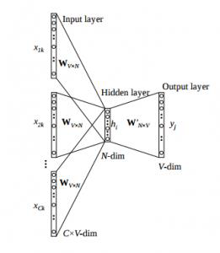

***Figure 2: CBOW***

The weight between Hidden layer and Output layer W’VxN is taken as Word Embedding, in which V: vocabulary size, N: number of features of word (hyper-parameter)

o Skip-gram

Skip – gram follows the same topology as of CBOW. It just flips CBOW’s architecture on its head. The aim of skip-gram is to predict the context given a word

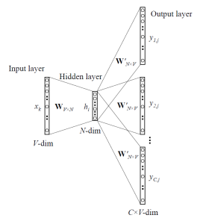

***Figure 3: Skip-gram***

The weight between Input layer and Hidden layer WVxN is taken as Word Embedding, in which V: vocabulary size, N: number of features of word (hyper-parameter)

1. Word Segmentation

The author of the the [14] project dicided to use syntactic parsers as tool for editors, which can extract candidates for phrase/word entry, the tool is called vnTokenizer, a highly accurate segmenter which uses a hybrid approach to automatically tokenize Vietnamese text. In practice, they consider dictionary words as candidate for word segmentation and make decision using context. Types of word that are considered in word segmentation phase include: single words, compound words, repeated words, idioms, proper Vietnamese Language and Speech Processing names, date/time, number expressions, foreign words, abbreviations.

[ For the task of word segmentation, we used vnTokenizer, a highly accurate segmenter which uses a hybrid approach to automatically tokenize Vietnamese text. The approach combines both finite-state automata technique, regular expression parsing, and the maximal-matching strategy which is augmented by statistical methods to resolve ambiguities of segmentation (Phuong et al., 2008).]

1. POS TAG

Post tagger is most commonly use tool to do the task

Because of the nature of [12] project, which is sentiment analysis base on task, the team needed to use POS tag. And use POS tagger tool to do the task

In [14], they choose first two criteria, combination ability and syntactic function, for POS tag set design. Therefore their POS tag set will not contain morphological information (number, aspect, tense, etc.), sub-categorization information (transitive/intransitive verbs, verbs followed by clauses, etc.), and semantic information.[ We used JVnTagger, a POS tagger based on Conditional Random Fields (Lafferty et al., 2001) and Maximum Entropy (Berger et al., 1996). This tagger is also developed under supported of VLSP project. Training data size is 10,000 sentences. Experiments with 5-fold cross validation showed that F1 scores for CRFs and Maxent are 90.40% and 91.03% respectively.]

## VietTreeBank[14]

In machine learning field, Treebanks are usually used as a tool to do most tag in the pre-process data step, such as training syntactic parsers, part-of-speech taggers, and word segmenters. For Vietnamese spicificly, VietTreebanks choose to use constituency representation of syntactic structures. There are three level of notation for VietTreebanks which include word segmentation, POS tagging, and syntactic labeling.

[These systems then can be used for applications such as information extraction, machine translation, question answering, and text summarization.] Since Vietnamese word order is quite fixed, VietTreebanks choose to use constituency representation of syntactic structures. Using annotation scheme proposed by Marcus et al. (1993). For Vietnamese, there are three annotation levels including word segmentation, POS tagging, and syntactic labeling. The goal is to build a corpus of 10,000 syntactically-annotated sentences (trees) and an additional POS tagged data set of 10,000 sentences. Raw texts are collected from a newspaper source, the Youth online daily newspaper (Tuoi tre online), with a number of topics including social and politics.VietTreeBank completed about 9,500 trees and 10,000 POS tagged sentences. For automatic labeling tools, they use CRFs for POS tagging or LPCFGs for syntactic parsing. In addition to treebank, other textprocessing resources and tools include: Vietnamese machine readable dictionary, EnglishVietnamese parallel corpus, word segmenter, POS tagger, chunker, and parser. Treebank and tools are closely related. Tools are trained using treebank data, and then they can be used in treebank construction.

* + 1. Word Segmentation in VietTreeBank

Dictionary editors may want to extract phrases from text which need to be explained in meaning. For this application, syntactic parsers can be used as tool for editors. Parsers can extract candidates for phrase/word entry. The following word types are considered in word segmentation phase: single words, compound words, repeated words, idioms, proper Vietnamese Language and Speech Processing names, date/time, number expressions, foreign words, abbreviations. Word segmentation ambiguity is the major problem annotators have to deal with. Suppose that three words “nhà cửa”, “sắc đẹp”, and “hiệu sách” are being considered. Annotators need to identify these combinations as words in: a. Nhà cửa bề bộn quá b. Cô ấy giữ gìn sắc đẹp. c. Ngoài hiệu sách có bán cuốn này And not words in: a. Ở nhà cửa ngõ chẳng đóng gì cả. b. Bức này màu sắc đẹp hơn. c. Ngoài cửa hiệu sách báo bày la liệt. They consider dictionary words as candidate for word segmentation and make decision using context.

* + 1. POS Tagging and Syntactic Annotation Guidelines
       1. POS Tag Set

They choose first two criteria, combination ability and syntactic function, for POS tag set design. Therefore their POS tag set will not contain morphological information (number, aspect, tense, etc.), sub-categorization information (transitive/intransitive verbs, verbs followed by clauses, etc.), and semantic information.

* + - 1. Syntactic Tag Set

VietTreeBank tag set contains three tag types: constituency tags, functional tags, and null-element tags. They use the tag H to label phrase head. If a phrase has more than one head, connected by coordination conjunctions or commas, then all heads are labeled with H tag. Other treebanks often does not use head tag. Therefore researchers on syntactic parsing (Collins, 1999) used heuristic rules to determine CFG rules’ head. Machine learning methods also can be used (Chiang and Bikel, 2002). Null elements are often used for adjective clauses, ellipsis, passive voice, and topic.

* + - 1. Sentence and Phrase Analysis Techniques

Annotation of real text requires various techniques to be applied. Ambiguity may occur in many steps of analysis such as determining phrase’s head, discriminating between possible complements, discriminating between adjuncts and other sentence elements, etc. Sentence analysis techniques include deletion, substitution, insertion, transformation, questioning. These techniques exploit contextual information, word combination, word order, and functional words to disambiguation between possible structures.

* + 1. Annotation Process and Agreement

There are three annotation levels: word segmentation, POS tagging, and syntactic labeling. The word segmentation tool was used for the first annotation level (word segmentation) immediately. As to the other annotation levels (POS tagging and syntactic parsing), first several thousand sentences were labeled manually. After that a POS tagger and a parser are trained bimonthly, then the annotation task becomes semiautomatic. According to the annotation process, each sentence is annotated and revised by at least two annotators. The first annotator labels raw sentences or revises automatically-analyzed sentences. Then the second annotator revises the output of the first annotator. Table 2 shows a number of important corpus statistics such as sentence count, word count, and syllable count for two data sets. The average sentence length is about 21.6 words.

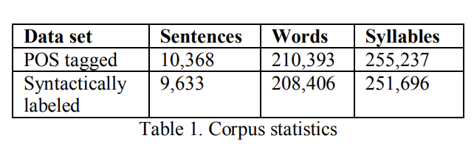

Annotation agreement measures how similar two texts annotated independently by different annotators are. Since this problem is similar to parsing evaluation, they use parseval measure. First, syntactic constituents in the form (i, j, label) are extracted from syntactic trees. Then tree comparison problem is transformed into constituent comparison. They compute three kinds of measurement: constituent and function similarity, constituent similarity, and bracket similarity. By using this method, they can evaluate both overall agreement and constituency agreement. Annotation agreement A between two annotators can be computed as follows:

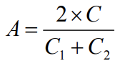

where C1 is the number of constituents in the first annotator’s data set, C2 is the number of constituents in the second annotator’s data set, and C is the number of identical constituents. Table 3 shows an example of constituent extraction from trees. From Table 3, compute: C1=6; C2=7; C=6; A=12/13=0.92 .

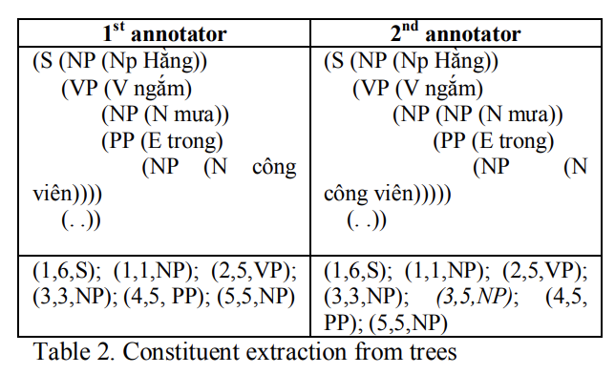

They carried out an experiment involving 3 annotators. They annotated 100 sentences and the result is shown in Table 3

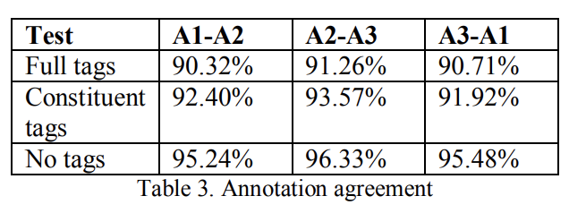

2.2 Neural Network

In the past, NLP task are usually solve using methods that are shallow machine learning models and time-consuming, hand-crafted features. This in term, has lead to numerous problems such as the *curse of dimensionality* since linguistic information was represented with sparse representations (high-dimensional features). However, in recent years, with the popularity and success of word embeddings (low dimensional, distributed representations), neural-based models have achieved superior results on various language-related tasks as compared to traditional machine learning models like SVM or logistic regression.

There are two main type of models in **Neural Network: Convolutional Neural Network and** Recurrent Neural Network

**. Convolutional Neural Network (CNN)**

A CNN is a neural-based approach which represents a feature function that is applied to constituting words or n-grams to extract higher-level features. The goal was to transform words into a vector representation via a look-up table, which resulted in a primitive word embedding approach that learn weights during the training of the network (see figure below).

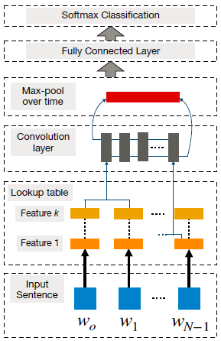

***Figure 4: CNN-based frameworks to NLP tasks***

In order to perform sentence modeling with a basic CNN, sentences are first tokenized into words, which are further transformed into a word embedding matrix (i.e., input embedding layer) of d dimension. Then, convolutional filters are applied on this input embedding layer which consists of applying a filter of all possible window sizes to produce what’s called a feature map. This is then followed by a max-pooling operation which applies a max operation on each filter to obtain a fixed length output and reduce the dimensionality of the output. And that procedure produces the final sentence representation.

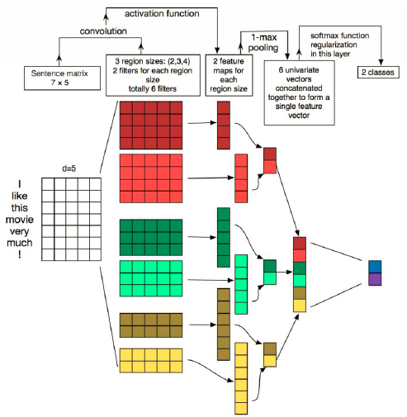

***Figure 5: CNN-based frameworks example***

By increasing the complexity of the aforementioned basic CNN and adapting it to perform word-based predictions, other NLP tasks such as NER, aspect detection, and POS can be studied. This requires a window-based approach, where for each word a fixed size window of neighboring words (sub-sentence) is considered. Then a standalone CNN is applied to the sub-sentence and the training objective is to predict the word in the center of the window, also referred to as word-level classification.

One of the shortcoming with basic CNN is there inability to model [long distance dependencies](http://compling.hss.ntu.edu.sg/courses/hg4041/pdf/lec-11-ldd.pdf). However, some of these studies reported that external knowledge was necessary when applying CNN-based methods to microtexts such as Twitter texts.

Overall, CNNs are effective because they can mine semantic clues in contextual windows, but they struggle to preserve sequential order and model long-distance contextual information. Recurrent models are better suited for such type of learning.

**Recurrent Neural Network (RNN)**

* RNN

A recurrent neural network (RNN) is a class of artificial neural network where connections between nodes form a directed graph along a sequence. This allows it to exhibit temporal dynamic behavior for a time sequence. Unlike feedforward neural networks, RNNs can use their internal state (memory) to process sequences of inputs. This makes them applicable to tasks such as unsegmented, connected handwriting recognition or speech recognition.

RNN are specialized neural-based approaches that are effective at processing sequential information. An RNN recursively applies a computation to every instance of an input sequence conditioned on the previous computed results. These sequences are typically represented by a fixed-size vector of tokens which are fed sequentially (one by one) to a recurrent unit. The figure below illustrates a simple RNN framework.

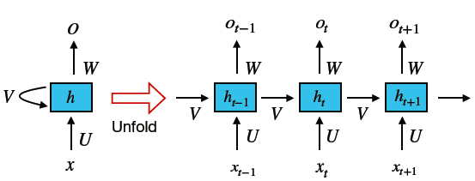

***Figure 6: Recurrent Neural Network framework***

The main strength of an RNN is the capacity to memorize the results of previous computations and use that information in the current computation. This makes RNN models suitable to model context dependencies in inputs of arbitrary length so as to create a proper composition of the input. RNNs have been used to study various NLP tasks such as machine translation, image captioning, and language modeling, among others.

The inputs expected by a RNN are typically one-hot encodings or word embeddings, but in some cases they are coupled with the abstract representations constructed a CNN model. Simple RNN suffer from the vanishing gradient problem which makes it difficult to learn and tune the parameters in the earlier layers. Other variants, such as LSTM netwoks, residual networks (ResNets), and gated-recurrent networks (GRU) were introduced to overcome this limitation.

RNN Variants: An LSTM consist of three gates (input, forget, and output gates), and calculate the hidden state through a combination of the three. GRUs are similar to LSTMs but consist of only two gates and are more efficient because they are less complex. They are usually picked based on the computing power available. Various LSTM-based models have been developed for sequence to sequence mapping (via encoder-decoder frameworks) that are suitable for machine translation, text summarization, modeling human conversations, question answering, image-based language generation, among other tasks.

### VIETNAMESE LANGUAGE AND SPEECH PROCESSING (VLSP) 2018[11]

With VLSP 2018, the goal is to identify a set of {aspect, polarity} tuples that summarize the opinions expressed in the review given a customer review about a target entity. Aspect is a pair of entity–attribute, while polarity can be “positive”, “negative” or “neutral”.

The task considers reviews in two domains: Restaurant and Hotel.

The subtask 2 of VLSP 2018 is focus on (Aspect-Polarity): The participants are required to identify both aspects and sentiment polarities. The dataset is taken from review site of hotel and restaurant. Using mostly SVM (more detail in the table) to build the model and predict. With the score in the table below:

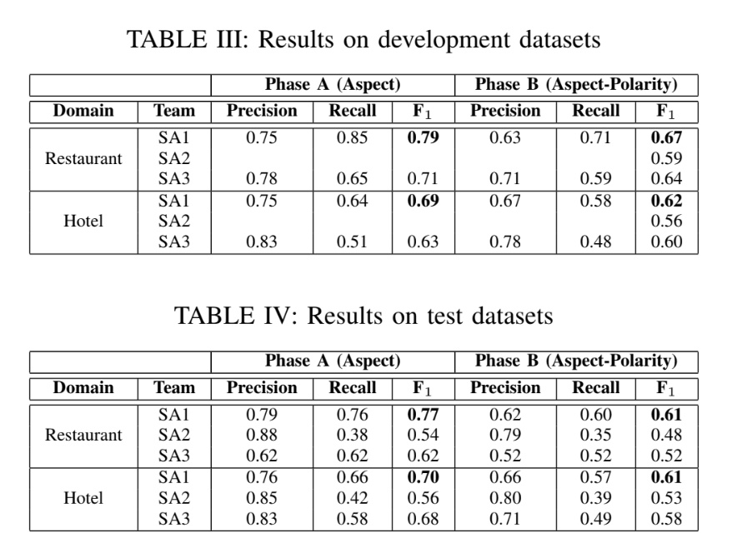

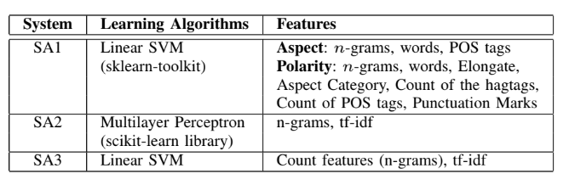

While SA2 and SA3 considered the task as a multi-class classification problem (each label is a pair of aspect-polarity) and built only one classifier to solve the task, SA1 treated the task as multiple binary classification problems and built a single binary classifier for each aspect. To identify polarities of reviews, SA1 modeled the problem as a classification with three classes, i.e. positive, negative, and neutral.

Table II summarizes learning algorithms and features used in participating systems. While SA1 and SA3 used SVM with linear kernel, SA2 exploited multilayer perceptron algorithm. SA2 and SA3 built only one multi-class classifier with basic features, including n-grams and tf-idf scores. SA1 used more sophisticated features, such as elongate features, hagtags, punctuation marks. SA1 also conducted some preprocessing steps before training classification models.

B. Results

Tables III and IV summarize results of participating systems on development and test datasets, respectively. For both domains, SA1 achieved the best F1 scores on both development and test datasets. The results showed the effectiveness of sophisticated features used in SA1. Using linear SVM, SA1 and SA3 outperformed SA2 with multilayer perceptron significantly.

### UIT-VSFC: Vietnamese Students’ Feedback Corpus for Sentiment Analysis[12]

The UIT-VSFC corpus is annotated for two different tasks: sentiment-based and topic based classifications. Ensuring the quality of corpus is one of the most important issues in the annotation process of the corpus. Therefore, they build a clear and complete annotation guidelines to control the annotation consistency and accuracy of the corpus. The annotation guidelines are designed for two separate tasks: sentiment-based and topic-based. The guidelines are not only useful for annotators but also important documents for researchers

concerning sentiment analysis and education.

The two key contributions are:

1) Obtain Vietnamese students’ feedback corpus (UIT-VSFC) for sentiment analysis and education research. As a result, they achieved over 16,000 sentiment-labeled and topic labeled sentences.

2) Analyzed the characteristics of Vietnamese students’ feedback and pointed out the challenges of annotating the corpus, which is crucial to build clear and complete annotation guidelines for annotators to control the quality of the corpus and support to build classification models on the corpus.

* + 1. DESCRIPTION

A. Task Definition

There are two subtasks: sentiment-based and topic-based.

• Sentiment-based task:

Given a Vietnamese student’s feedback sentence, determine whether it expresses a positive, negative, or neutral/objective sentiment. For example, annotated sentences are shown in the Table I and the sentiment polarities are shown in the third column of the table respectively.

Each sentence is labeled one of three sentiment polarities including positive, negative, and neutral. Annotation guidelines are briefly described as follows.

* Positive polarity: Sentences in which students use to express their satisfaction and compliments about elements of teaching activities such as lecturers, subjects, assignments, etc
* Negative polarity: Sentences express students’ dissatisfaction, requests, and complaints related to Lecturer, Curriculum, Facility, and so on.
* Neutral polarity: Sentences are incomplete or unclear in meaning or do not contain opinions, for instance, the sentence "giờ_giấc và cách giảng dạy" (means: time and teaching methods) is a neutral sentence which is actually a noun phrase and does not contain any words expressing emotions. Or, sentences are complete but do not express any students’ feelings.

• Topic-based task:

Given a Vietnamese students’ feedback sentence, decide whether it expresses information related to Lecturer, Curriculum, Facility, or Others. The labeled examples with related topics which are shown in the fourth column of Table I respectively.

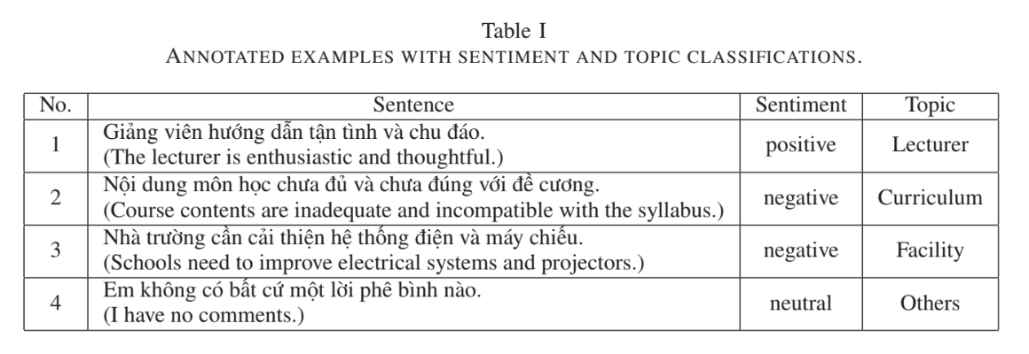

In this task, the author divided the topics which students are most interested in into four major classifications consisting of Lecturer, Curriculum, Facility, and Others:

• Lecturer: Sentences express emotions about teaching methods, attitudes, knowledge, and so on. Detecting these feedback related to lecturers help to improve the quality of lecturers’ teaching activities. As an example, the given sentence "Thầy có phương pháp giảng dạy rất hay." (means: "You have a great teaching method.") portrays the compliment about a lecturer, therefore, this sentence is assigned to the Lecturer topic.

• Curriculum: Sentences express the sentiment about matters related to subjects, curriculum, assignments, grades, session time, knowledge, labs, etc. For example, the given sentence "Môn_học này rất cần_thiết và bổ_ích." (means:"This subject is very necessary and beneficial.") is assigned to the Curriculum category.

• Facility: There are students’ feedback related to facilities such as computers, electric lights, projectors, fans, etc. For example, the given sentence "Máy tính phòng lab chạy quá chậm." (means: "The lab computers run slowly.") is labeled with Facility.

• Others: Sentences, which are unclear or belong to other than the above topics, do not express any certain topics, so it belongs to the others type. For instance, the sentence "Em không hài_lòng." (means: "I’m not satisfied.").

There are sentences which express both negative and positive emotions which are difficult to judge. They are often complex sentences with conjunctions such as nhưng (but), tuy nhiên (however), etc. In this cases, the annotators are asked to chose the stronger polarity based on their understanding. Example sentence "Thầy dạy dễ hiểu nhưng nhiều lúc hơi nhanh." (means: "The teacher’s taught was easy-to-understand but sometimes fast.") is assigned to the negative polarity, although it contains the positive clause "The teacher’s taught was easy-to-understand."

* + 1. CORPUS BUILDING PROCESS

A. Collecting Data

Students’ feedback in the project were from a university in Vietnam, which were collected through student surveys by the university at the end of each semester from 2013 and 2016 with more than 16,000 students’ sentences. Table II shows the detailed information of the collected data.

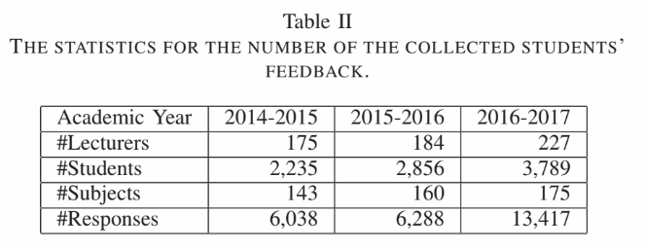

B. Pre-processing

The normalization is done using NLP tools effectively such as POS taggers and parsers in the process of building models. Firstly, they segment student’s feedback into sentences. Then replace abbreviations with complete words and correct the misspelling. The abbreviations and spelling mistakes are stored in a dictionary for media data mining. As a result, the project obtain over 16,000 normalized sentences in this phase.

C. Annotation Process

The author build the basic guidelines as completely as possible before starting the annotation process. They also update the annotation guidelines during the annotation process, which is necessary because there are many complicated cases. When finding a difficult case, they will update the guidelines. After updating the guidelines, they re-train the annotators with the revised guidelines. Eventually, they evaluate the corpus based on inter-annotator agreements and classification experiments.

D. The resulted corpus

They obtained over 16,000 sentiment-labeled and topic labeled sentences. Table III shows the distribution of sentiment and topic classes of the corpus.

Table III

DISTRIBUTION OF THE CORPUS ON SENTIMENTS AND TOPICS (%).

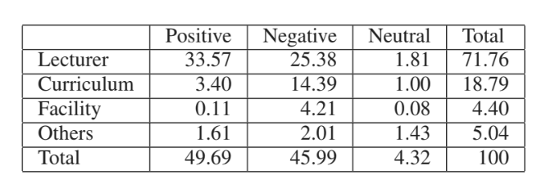

The distribution of sentiment-based sentences according to the length of the sentence was presented in Table IV.

Table IV DISTRIBUTION OF SENTIMENT-BASED SENTENCES ACCORDING TO THE LENGTH OF THE SENTENCE (%).

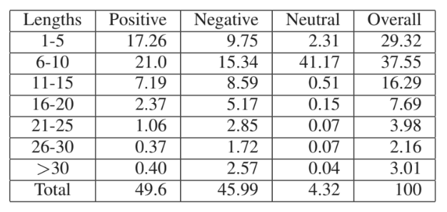

* + 1. CORPUS EVALUATION

1. Inter-Annotator Agreements

In order to calculate inter-annotator agreements, they follow the agreement measure Am [20] which is defined as the proportion of agreement after the chance agreement is removed from consideration, given by the following formula.

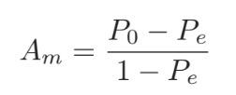

Where, the observed agreement (P0) is the proportion of sentences which both of the annotators agreed on the classes pairs and the chance agreement (Pe) is the proportion of items for which agreement is expected by chance when the sentences are seen randomly. Table VI shows the agreement measure of the corpus on three annotators for two tasks. With regard to the sentiments, the Am agreement and the observed agreement are very high with 91.20% and more than 95% respectively. Besides, the Am agreement of topics is 71.07%, whereas the topic observed agreement is higher than that with 90.33%. As a result, the agreement of sentiment is much higher than that of topics, over 20%. This implies that the annotators identify the sentiment polarities easier than the topics.

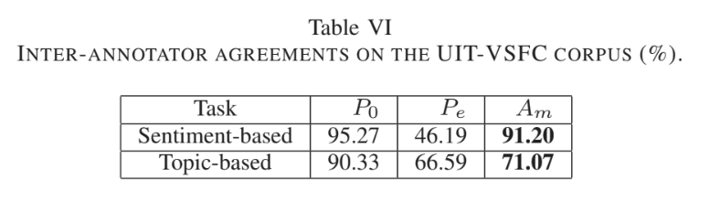

B. Experimental Results

1) Setting: They implement two classifiers as Naive Bayes and Maximum Entropy on the corpus. In addition, they also use the five-fold cross-validation scheme. The result are calculate using four evaluation metrics such as accuracy, precision, recall and F1-score. To create the training, development, and test datasets, the original corpus was split randomly into three parts which cover approximately 70.0%, 10.0%, and 20.0% respectively.

Table VII shows statistics of these datasets in number of tokens and number of sentences. They used two available tools for classification experiments, the Datumbox framework [18] and the Stanford Classifier [17] for Naive Bayes and Maximum Entropy respectively.

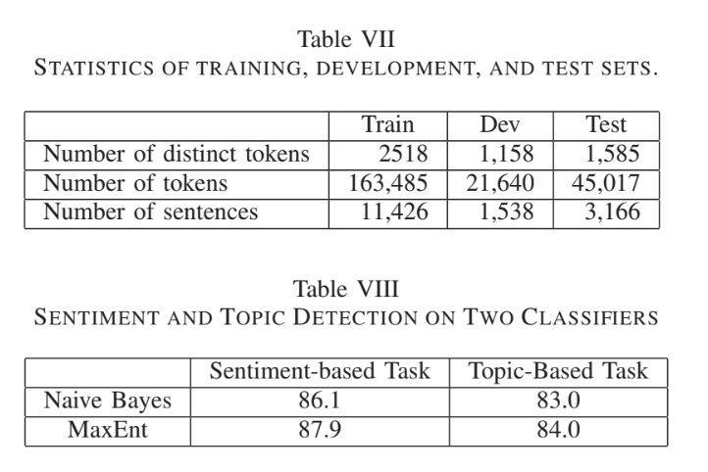

2) Sentiment Classification Results:

The performance of MaxEnt classification on sentiment-labeled data is better than that of Naive Bayes, as can be seen in Table VIII. The precision, recall and F1-score of the sentiment MaxEnt model on the test dataset are shown in Table IX. The results on both positive and negative are high with F1-score, 91.32% on the positive examples and 90.52% on the negative examples, whereas the performance on the neutral examples is low with the only 33.99%. This is because the corpus is unbalanced, for instance, the neutral data occupy 4.32% of the corpus.

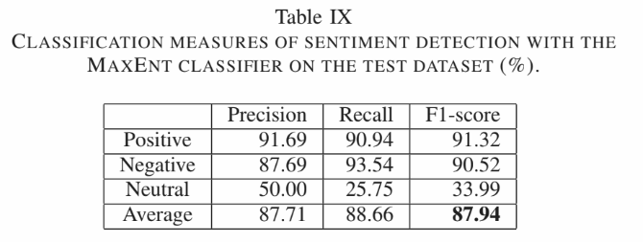

3) Topic Classification Results:

The performance of Max-Ent classification on topic-labeled data is better than that of Naive Bayes, as can be seen in Table VIII. Table X shows the precision, recall and F1-score of the topic MaxEnt model. The result of the Lecturer class is high with the F1-score of 91.12%, whereas the figure for the Curriculum class are low with 67.19% of the F1-score. The overall measurement of topics is over 84%, lower than that of sentiments. In general, the quality of the classifications still needs further improvements.

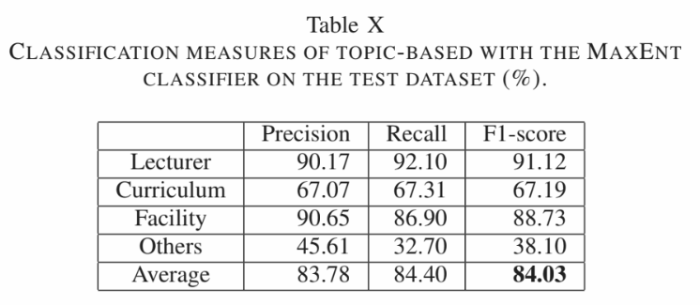

# CHAPTER 3

# IMPLEMENTATION

### User requirement analysis

The goal is to create a chatbot for school website, whom students can leave the review about the school or they can ask question about the school. To do this, the bot will need to be identified what is the user input (a question or a review) to make the right response. The bot will also need to be able to analyze sentimental of the sentence to make the response feel more friendly and not like a machine. For the question, the bot will need to be automatically detect the keywords of the user input to make the search for the answer in the database

### Training system design

### Choosing CNN or RNN

RNN have been used to study various NLP tasks such as machine translation, image captioning, and language modeling, among others.

As it compares with a CNN model, an RNN model can be similarly effective or even better at specific natural language tasks but not necessarily superior. This is because they model very different aspects of the data, which only makes them effective depending on the semantics required by the task at hand.

Overall, RNN are used for many NLP applications such as:

* Word-level classification (e.g., NER)
* Language modeling
* Sentence-level classification (e.g., sentiment polarity)
* Semantic matching (e.g., match a message to candidate response in dialogue systems)
* Natural language generation (e.g., machine translation, visual QA, and image captioning)

So, in conclusion, if the task required to identify multiple features, then CNN would prove to be usefull, but this project only have 2, which are “positive” and “negative”, and the task requires more about how each word relates to each other to create a meaningfull comment, so I choose RNN.

### Choosing NLP tool

I decided to use UnderTheSea[13] tool kit for POS tagging for the input   
Underthesea is a suite of open source Python modules, data sets and tutorials supporting research and development in Vietnamese Natural Language Processing. Their tool kit can be used for Word Segmentation, Pos Tag and Chunking, which is needed for this project**.**

### Choosing training tool

I choose TensorFlow library for the support of using GPU to train to reduce the it need. It is also easier to set up the option and esier to create training model

### Getting Data

The dataset that contain vector for each vietnamese word are found here:  
https://s3-us-west-1.amazonaws.com/fasttext-vectors/word-vectors-v2/cc.vi.300.vec.gz

The dataset for positive and negative review was found on https://streetcodevn.com/blog/dataset

Containing review from Foody save in .txt files

For question file, I use a program call Facepager to get all the post made by IU confession page and export it as a scv file.

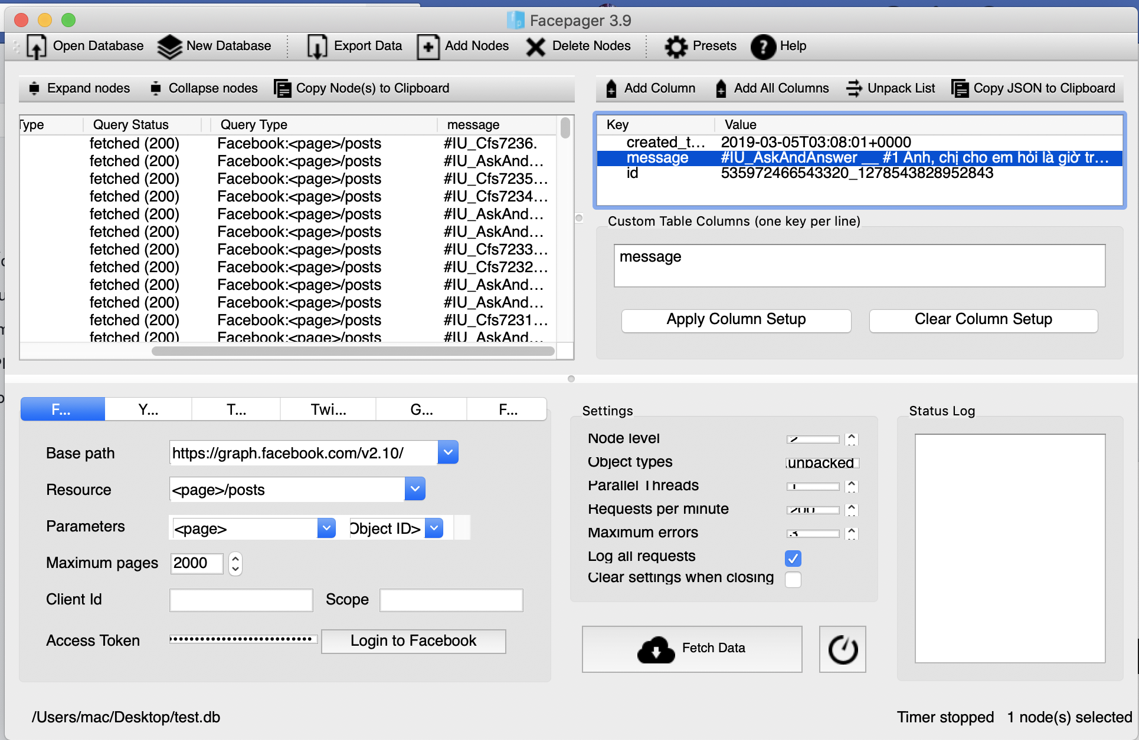

The using Regex, I extract all the post that had the #IU_AskAndAnswer as question and #IU_Cfs as normal review:

question_data = [ ]

review_data = [ ]

For mess in Data:

review = regex.compile('#IU_Cfs' )

question = regex.compile('#IU_AskAndAnswer')

if question.search(mess):

question_data.append(mess)

if review.search(mess):

review_data.append(mess)

Then I save the array as txt file with each line contain one question. I aloso used Regex to pre-process the data, eliminate all the symbal, which result in about 1184 question.

I also took about 700 question from this project: <https://github.com/thtrieu/qclass_dl/blob/master/datavn/test?fbclid=IwAR0jbvSGpOWRgpnJFM9hl2dELO_7itgEougBNZW8EcyYz7cHzTnCpd8JHY0>

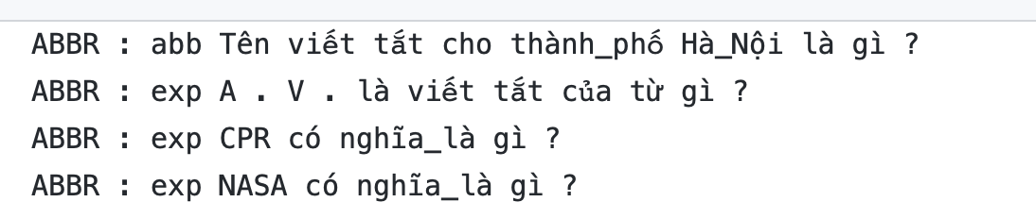  
Because I only need to training the bot to recognize if the input string is a question or a normal comment, so I used Regex again to remove the classification of the question in the data. This leave me with about 1894 sentenses of question to train

### Pre-process weight vector

The data taken from Wikipedia contain 3 million words, contain in an array, with each word is in index 0, follow by 300 number in the following index to represent the weight vector of that word.

This prove to be not effician because the model need weight vector as an separate array. So I convert the vec file into hdf5 file as an hash table. The key “words” contain an array of 3 million word while the key “vector” contain an array of weight vector of each words with the index of each word match the index of the weight vector.

### Pre-process data

In this step, each line of the data is read seperatedly, then each word in the line are convert to the index number of word in wordlist, using Tensorflow library “tf.nn.embedding lookup” to find the vectors based on indices

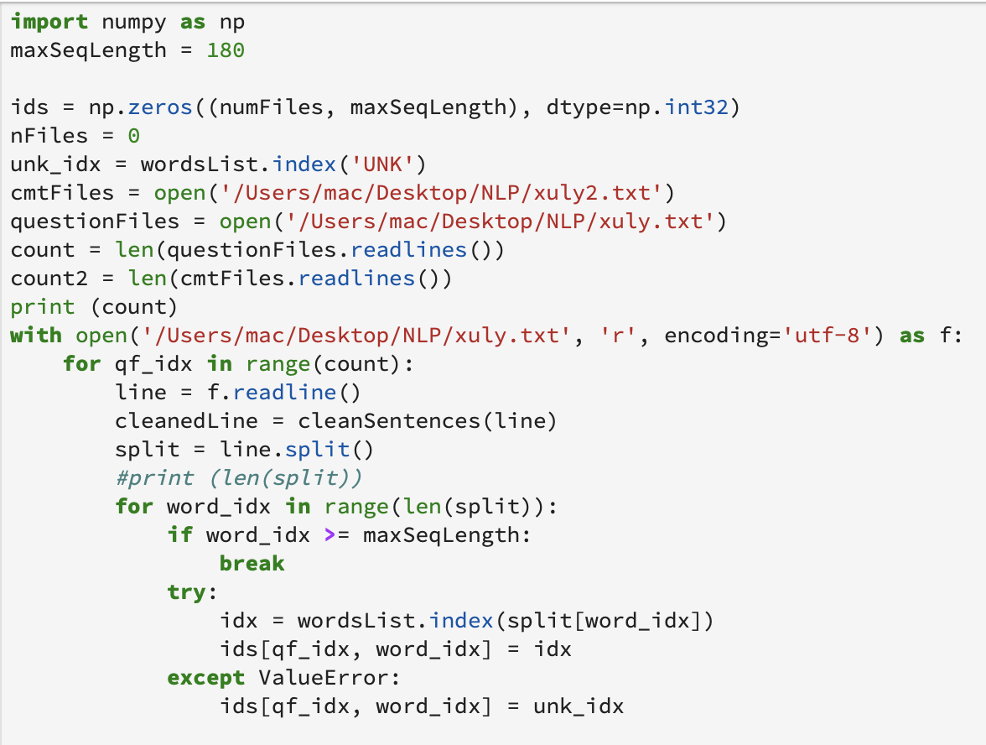

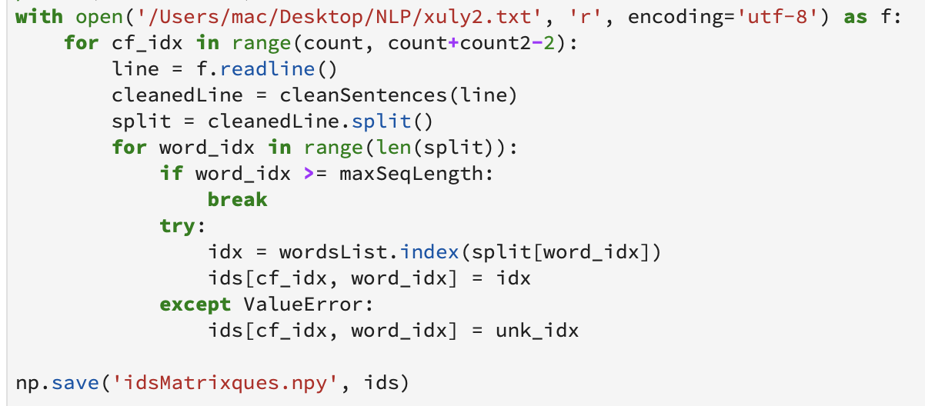

### Bulding the model

First, I plot out the length of each review in the data

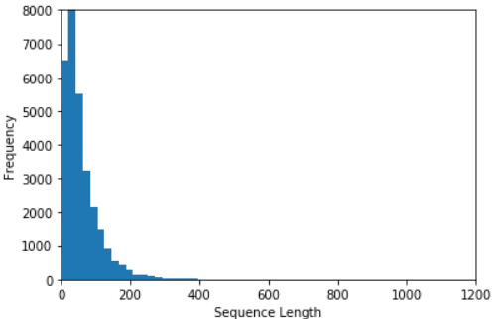

Based on the plot, it can be see that most of the sentences are in the 180 words lengh, so Maximum Sentence Length to 180 is the best option

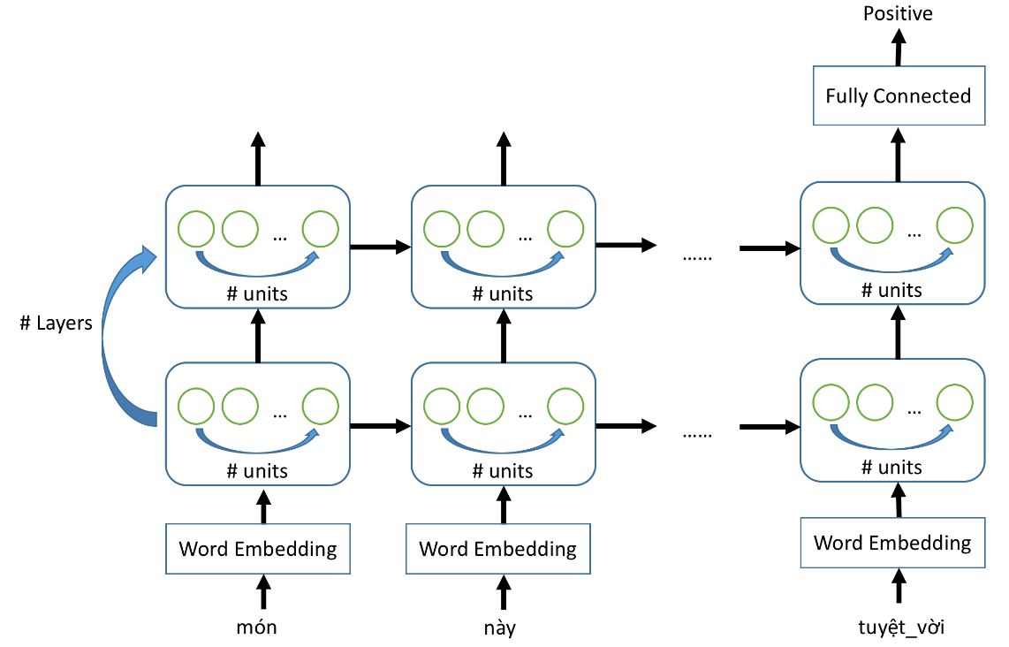

Like mention before, I have decided to use RNN model. For that, I choose to build the model using Keras-Tensorflow because Keras is a user-friendly neural network library written in Python, most of the function are in the library and I can call it easily. Another advantage of Keras is that modular so I can easily change the component of the model to see what give the best result.

The Sequential API allows you to create models layer-by-layer for most problems. It is limited in that it does not allow you to create models that share layers or have multiple inputs or outputs. Because my project is straightforward, I only need to to predict if a sentence is a question or a review, then do the sentimental analysis if it a review, so I only need to use sequential model

[Adam is an adaptive learning rate method, which means, it computes individual learning rates for different parameters

Another trick that Adam uses is to adaptively select a separate learning rate for each parameter. Parameters that would ordinarily receive smaller or less frequent updates receive larger updates with Adam (the reverse is also true). This speeds learning in cases where the appropriate learning rates vary across parameters. For example, in deep networks, gradients can become small at early layers, and it make sense to increase learning rates for the corresponding parameters. Another benefit to this approach is that, because learning rates are adjusted automatically, manual tuning becomes less important. Standard SGD requires careful tuning (and possibly online adjustment) of learning rates, but this less true with Adam and related methods. It's still necessary to select hyperparameters, but performance is less sensitive to them than to SGD learning rates.]

I choose Sidmoid as the activation function is because the sigmoid function exists between **(**0 to 1). Therefore, it is especially used for models where we have to predict the probability as an output. Since probability of anything exists only between the range of 0 and 1, sigmoid is the right choice.

The dense is 1 because I only need the output of a single number so only need 1 dimension

The file already have the weight vector so I use an embedding layer with the

With Keras, I can create multiple layer by using the add() function, my basic training model is as follow:

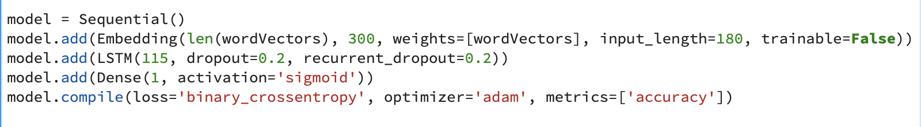

[The function is **differentiable**.That means, we can find the slope of the sigmoid curve at any two points.

The function is **monotonic**but function’s derivative is not.

The logistic sigmoid function can cause a neural network to get stuck at the training time.

The **softmax function** is a more generalized logistic activation function which is used for multiclass classification.]

[Keras is the tool to create Tensorflow model]

[Keras is a user-friendly neural network library written in Python. In this tutorial, I will go over two deep learning models using Keras: one for regression and one for classification. We will build a regression model to predict an employee’s wage per hour, and we will build a classification model to predict whether or not a patient has diabetes]

[[Keras](https://keras.io/) is a high-level neural networks API, capable of running on top of [Tensorflow](https://github.com/tensorflow/tensorflow), [Theano,](https://github.com/Theano/Theano) and [CNTK](https://github.com/Microsoft/cntk). It enables fast experimentation through a high level, user-friendly, modular and extensible API. Keras can also be run on both CPU and GPU.]

[The easiest way of creating a model in Keras is by using the sequential API, which lets you stack one layer after the other. The problem with the sequential API is that it doesn’t allow models to have multiple inputs or outputs, which are needed for some problems.

Nevertheless, the sequential API is a perfect choice for most problems.

To create a [convolutional neural network](http://cs231n.github.io/convolutional-networks/) we only need to create a Sequentialobject and use the add function to add layers]

### Server/API

Because the main function of the bot is machine learning, which will use Python language to analysis the input, I decided to use Python as the main language to build the web server also. To do this, I will use Python-Flash library to create the necessary API for the website. I will also using websocket for the chat function of the bot to push message from the user back to the server and viceversa.

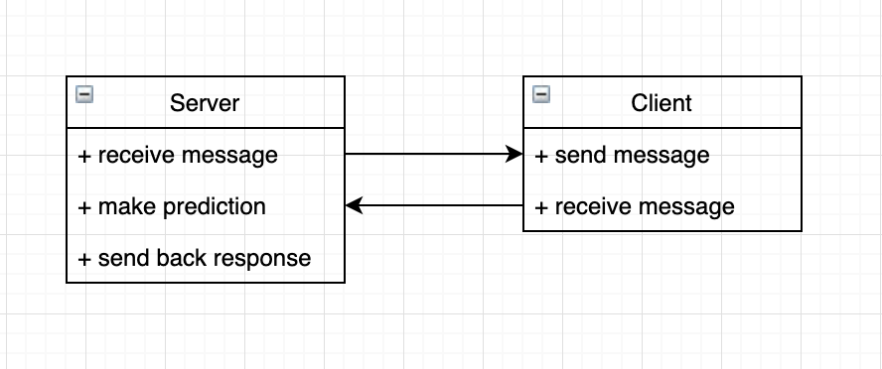

Server response flow   
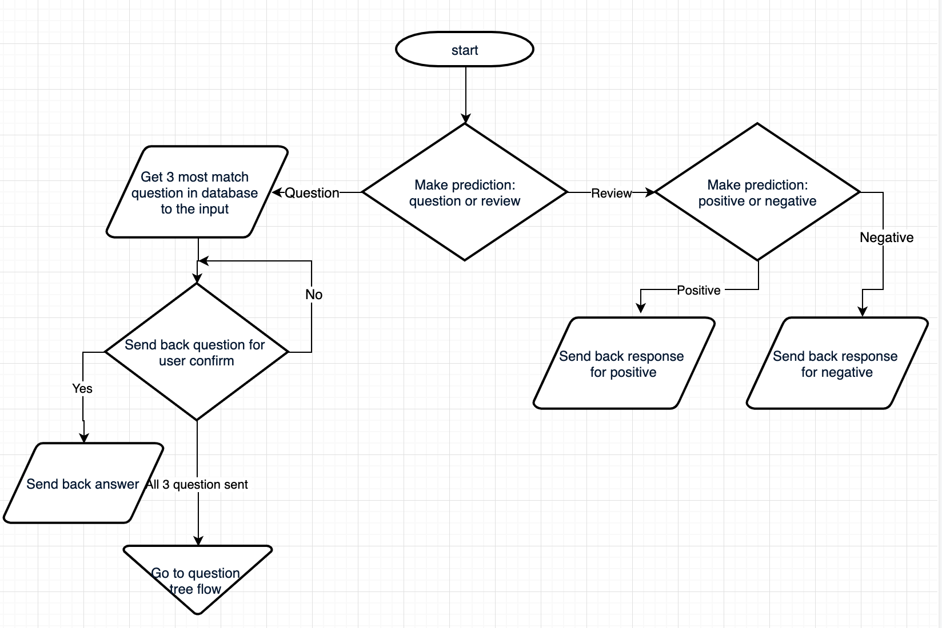

Question tree flow

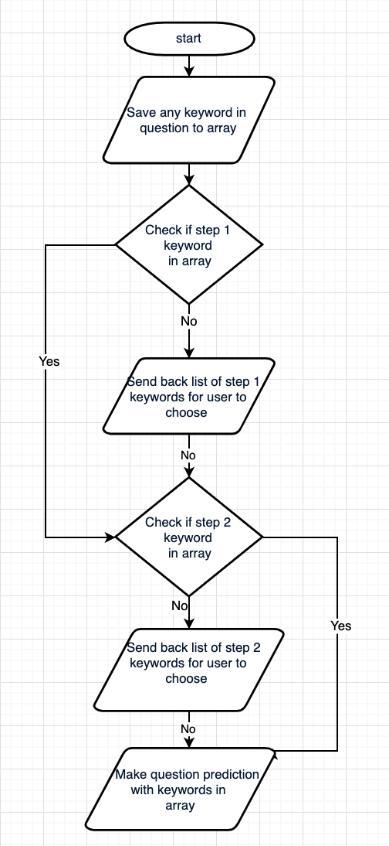

### User Interface (UI)

UI will be an HTML simple page with a login function to separate the user, connected to the server using Python Flask. The HTML will also have Java script to handle the form and other task in the HTML page



### Database design

Because the website only handle one chat windows with the bot, the database will only need two tables (User table and Messages table).   
The User table would save the user id, username and password

The message will save all the messages that had been sent with the username of which the message is sent from

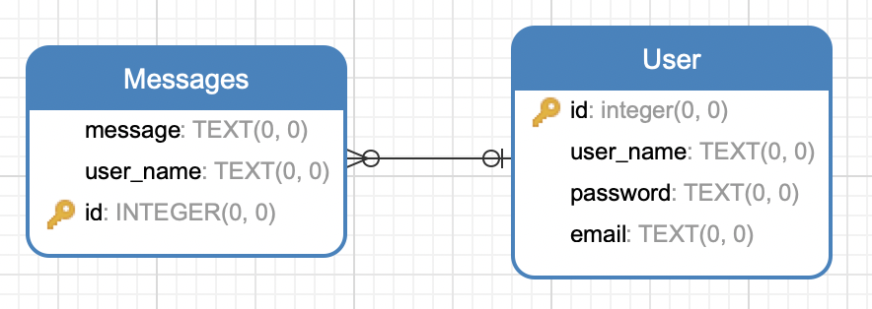

# CHAPTER 4

# EXPERIMENTS AND RESULTS

## Predict question or review

## Base model

First layer is an embedding layer to load in the weight  
Second layer is LSTM layer with 128



## Pre-process the embedding vector

The data taken from Wikipedia contain 3 million words, contain in an array, with each word is in index 0, follow by 300 number in the following index to represent the weight vector of that word.

This prove to be not effician because the model need weight vector as an separate array. So I convert the vec file into hdf5 file as an hash table. The key “words” contain an array of 3 million word while the key “vector” contain an array of weight vector of each words with the index of each word match the index of the weight vector.

## Pre-process the weight vector

Because the file already

I use FastText pre-trained model to do Word Embeddings

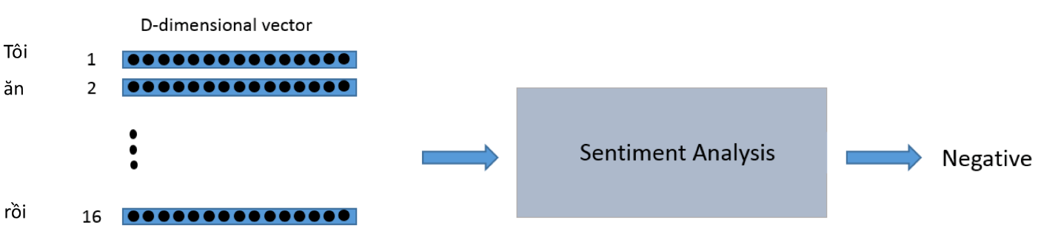

***Figure 8:Input/ Output in terms of Word Embedding***

Take the word “nha nuoc” as example:

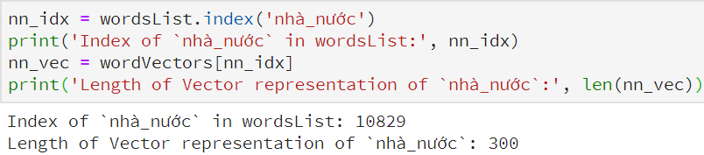

The word “nha nuoc” can be represented by the vector with the length of 300

Moreover, Word Embedding are also able to convert the sentence into the matrix. For example, the sentence “Món này ăn hoài không biết chán” can be represented as matrix by finding the indices of words in the dictionary “wordsList” and use Tensorflow library “tf.nn.embedding lookup” to find the vectors based on indices

Take the sentence “Món này ăn hoài không biết chán” as an example:

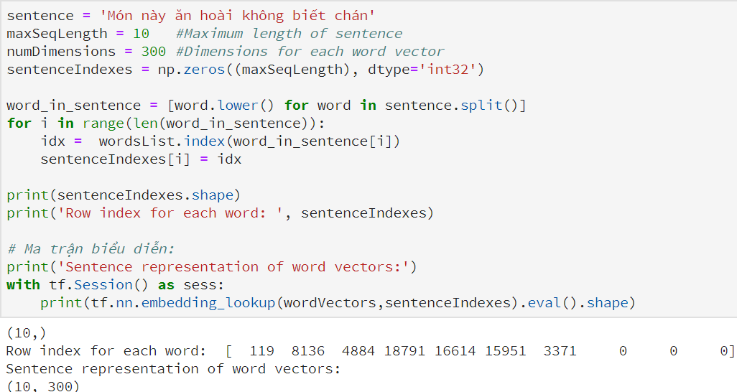

The sentence “Món này ăn hoài không biết chán” can be represented by the matrix with the dimension of (10, 300)

One hyper-parameter in Sentence Embedding is Maximum Sentence Length. If Maximum Sentence Length is large, it will not save the memory when representing the short comment. In contrast, if Maximum Sentence Length is small, it will miss some important words to analyze the sentiment. The idea to solve is plotting the frequency of Sentence Length to choose the most appropriate maximum sentence length

Figure 13: Frequency vs Sequence Length



Based on the plot, Maximum Sentence Length of 180 is the best option. The architecture I use in the project is Stacked LSTM with 2 layers



***Figure 9: Architecture***

## Word segment

Using regex to eliminate all the symbol and space

# 

## Vector value of each word in each review

Because both positive and negative reviewa are seprerated in a folder and does not have the weight vector yet, I take each review, then map each word in the review (I match each word inside each review and map it) to the weight vector and then save it to idsMatrix.npy

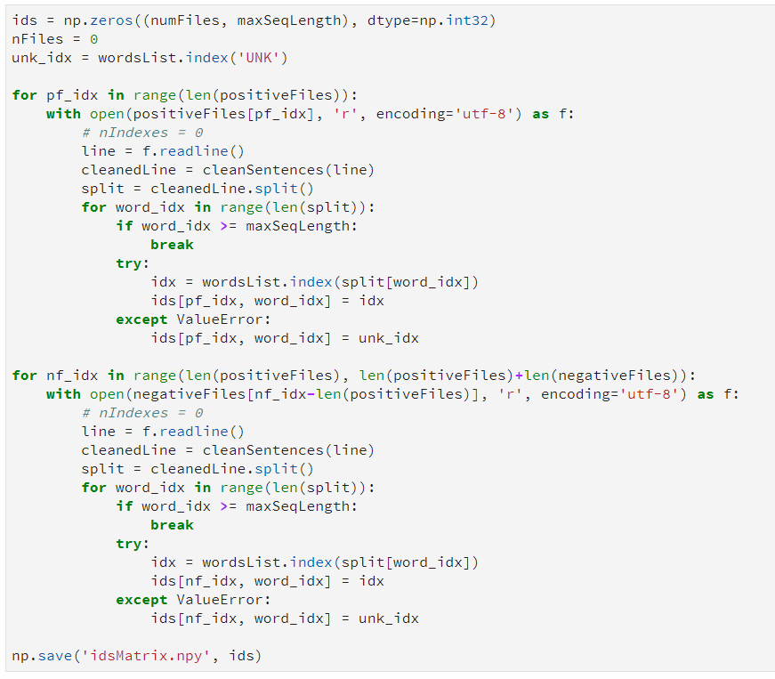

## Building train and test batch

When I map the positive and negative reviews to the vector, I intentionally save positive review at index from 1 to 15000 and negative at from 15001 to 30000, so now whenever making the train and test batch, I can map it to to label [1,0] for positive and [0,1] for negative I take the batch size of 64 and begin to take positive review in the range of 1 to 14000 and negative review in the range of 16001 to 30000 to train. The rest are use to test

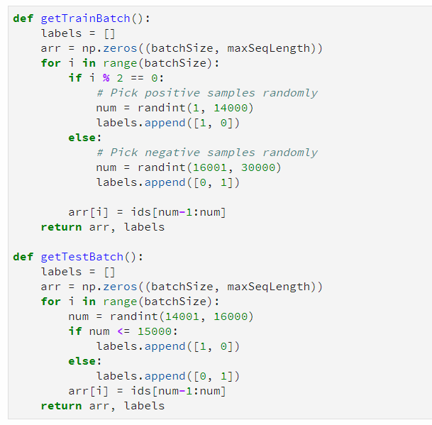

## Bulding RNN Model with Tensorflow

First i use LSTM as setting for cell of RNN model. With 128 units for each layer, the number of layers are 2, number of classes are 2 (positive and negative), and the number of iterations are 300000

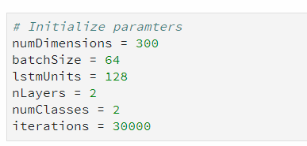

## Create input and output

For the data of input and output, i use placeholder. Then setting for the size of tensor, the output of the prediction will be a vector with one of two values ([1,0] for positive and [0,1] for negative).

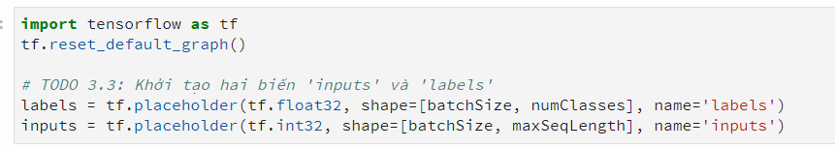



## Training the system

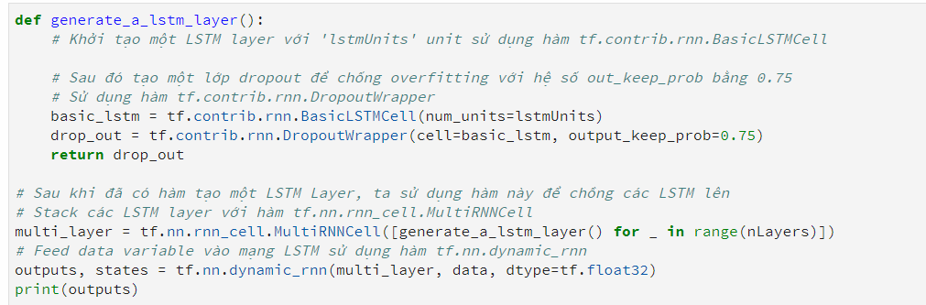

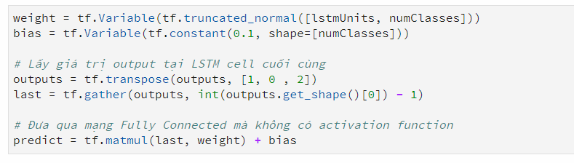





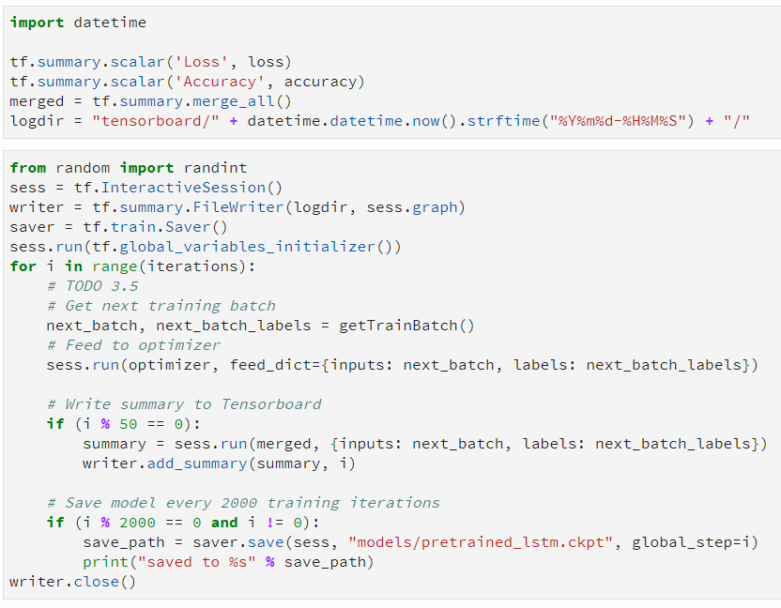

The model took me almost four hours to train with GPU of K80 on Google Colab and I also saved the weights on my computer to avoid the re-train. The accuracy in the whole 4-hour training process is in range of 75% - 85%.

## Test the model

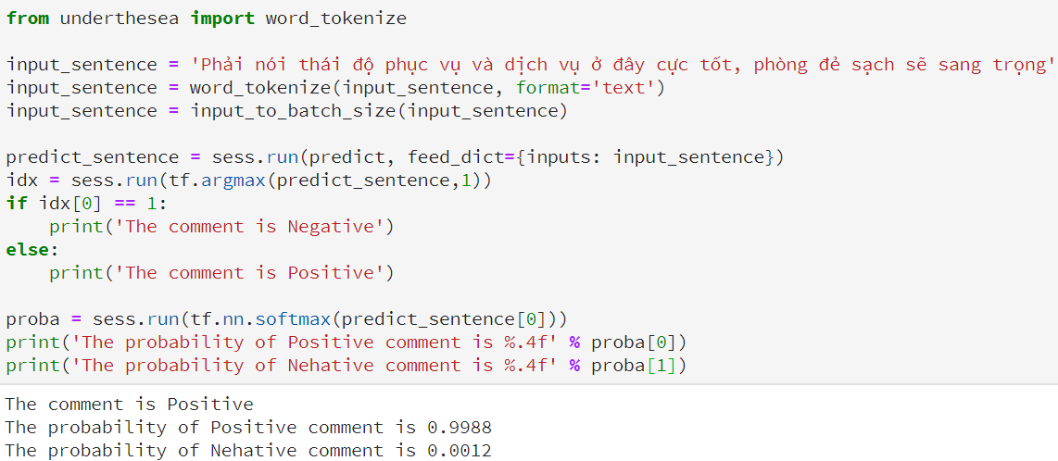

*Figure 15: Sample comment and result*

Take the sentence “Phải nói thái độ phục vụ và dịch vụ ở đây cực tốt, phòng đẻ sạch sẽ và sang trọng” as an example. The model predicts the Positive comment. Moreover, the model also shows the probability of each label.

## Results

Taking other comment from IU confession facebook page

Sentence: “Mình đã đăng kí số tài khoản ngân hàng theo link của nhà trường hồi cuối tháng 12, tên của mình trong danh sách sinh viên chưa đăng kí cũng đã mất nhưng tiền học bổng lại chưa về... :) Vậy là kì sau mình mới được nhận hả mấy bạn ơi :(((”  
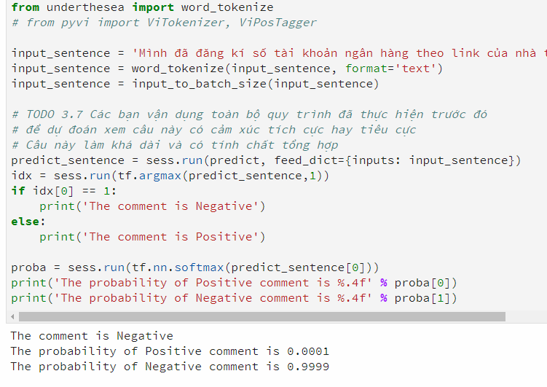

Sentence: “chào anh chị, em là k18 , em đang tính kiếm chỗ học thêm anh văn ở ngoài, có ai biết chỗ nào dạy tốt mà giá cả phải chăng ko chỉ em với. À với cho em hỏi hình như trong trường mình có trung tâm, ko biết học ở trung tâm trong trường được ko, ai biết tư vấn em với. Em cảm ơn.”

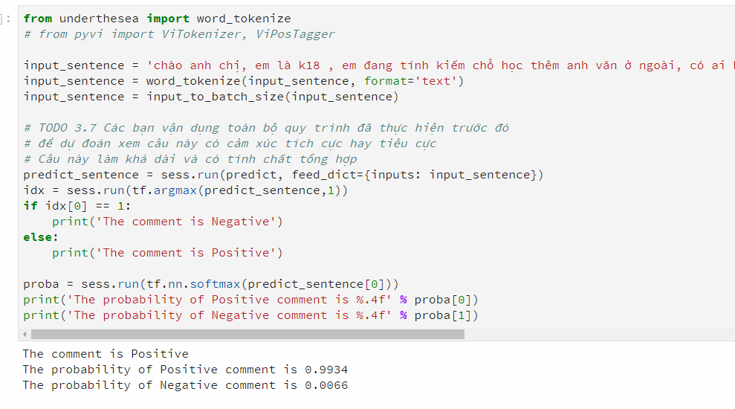

Sentence: “Lại là câu chuyện về máy lạnh bị hư.Mình học bên khu L và phòng L.107 hơn cả học kì này mỗi tuần máy lạnh đều ko họat động đc và cũng k có ai sửa. Phòng rất nóng và phải học vào buổi chiều. Hi vọng kì sau sẽ thay đổi và sửa lại máy lạnh, mình thấy có góp ý vô tờ đánh gía mà không biết phòng thiết bị có đọc đc không.”

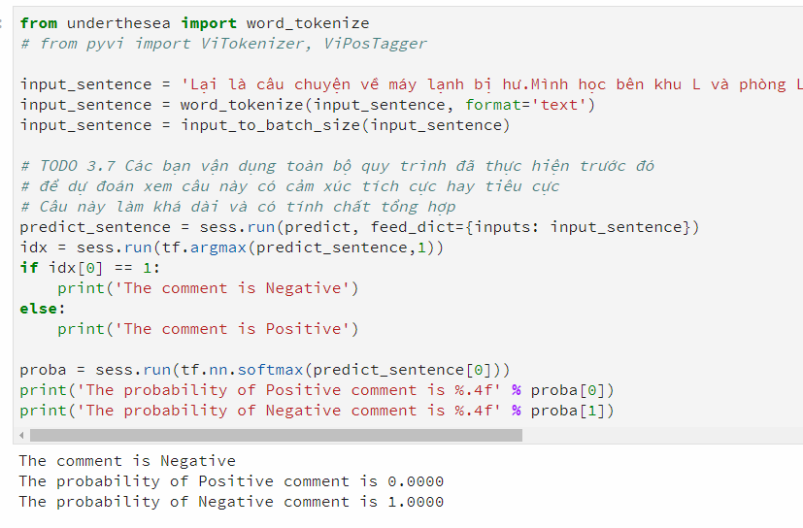

# CHAPTER 5

# CONCLUSION AND FUTURE WORK



## Conclusion

Right now, the system still can not detect question, it can only predict comment. Not only that, most neutral comments will make the system predict wrong because it only has two final predicts, which is “positive” or “negative”.

## Future work

There are still many to improve. Firstly, the data only work well with food reviews while i need to predict review related to education area, so i still need to make a dataset of school reviews for the system to train. After that, because my goal is to create a simple chatbot, i need to setup a set of responses for the system to send back

# REFERENCES

[1] Mitchell, T. (1997). *Machine Learning*. McGraw Hill. p. 2. ISBN 978-0-07-042807-2

[2] Stuart J. Russell, Peter Norvig (2010) *Artificial Intelligence: A Modern Approach, Third Edition*, Prentice Hall ISBN 9780136042594

[3] Ghahramani, Zoubin, and Michael I. Jordan. "Supervised learning from incomplete data via an EM approach." *Advances in neural information processing systems*. 1994.

[4] Hinton, Jeffrey; Sejnowski, Terrence (1999). *Unsupervised Learning: Foundations of Neural Computation*. MIT Press. ISBN 978-0262581684

[5] "Semi-Supervised Learning Literature Survey". 2007. CiteSeerX 10.1.1.99.9681

[6]  *Kaelbling, Leslie P.; Littman, Michael L.; Moore, Andrew W.(1996). "Reinforcement Learning: A Survey". Journal of Artificial Intelligence Research.****4****: 237–285. arXiv:cs/9605103. doi:10.1613/jair.301. Archived from the original on 2001-11-20.*

[7] Géron, Aurélien. *Hands-on machine learning with Scikit-Learn and TensorFlow: concepts, tools, and techniques to build intelligent systems*. " O'Reilly Media, Inc.", 2017.

[8] (Book) Deep Learning for Natural Language Processing - Jason Brownlee

[9] Understanding how to explain predictions with “explanation vectors” – Towards Data Science - Pol Ferrando

[10] Kuhlman, Dave. "A Python Book: Beginning Python, Advanced Python, and Python Exercises". Section 1.1. Archived from the original (PDF) on 23 June 2012.

[11] PEP 8100". *python*. Python Software Foundation. Retrieved 4 May 2019.

[12]  *"Flask Foreword"* (Flask official website) <http://flask.pocoo.org:80/docs/0.10/foreword>

[13] Glossary:WebSockets". Mozilla Developer Network. 2015.

[14] Janyce Wiebe and Theresa Wilson and Claire Cardie, Annotating expressions of opinions and emotions in language, Language Resources and Evaluation, 39, 165–210, 2005, Kluwer Academic Publishers.

[15] Bo Pang and Lillian Lee and Shivakumar Vaithyanathan, Thumbs up?: Sentiment classification using machine learning techniques, In Proceedngs of the Conference on Empirical Methods in Natural Language Processing - Volume 10 (EMNLP ’02), 2002, 79–86, Association for Computational Linguistics.

[16] Minqing Hu and Bing Liu, Mining and summarizing customer reviews, In Proceedings of the 10th ACM SIGKDD International Conference on Knowledge Discovery and Data Mining (KDD ’04), 2004, 168–177, New York, USA.

[17] Stefano Baccianella and Andrea Esuli and Fabrizio Sebastiani, SentiWordNet 3.0: An Enhanced Lexical Resource for Sentiment Analysis and Opinion Mining, SentiWordNet 3.0: An Enhanced Lexical Resource for Sentiment Analysis and Opinion Mining, 2010, 2200–2204, Valletta, Malta.

[18] Preslav Nakov and Sara Rosenthal and Zornitsa Kozareva and Veselin Stoyanov and Alan Ritter and Theresa Wilson, SemEval-2013 Task 2: Sentiment analysis, In Proceedings of the 7th International in Twitter Workshop on Semantic Evaluation, 2013, 312–320, Atlanta, Georgia, USA.

[19] Sara Rosenthal and Preslav Nakov and Svetlana Kiritchenko and Saif Mohammad and Alan Ritter and Veselin Stoyanov, SemEval-2015 Task 10: Sentiment analysis in Twitter, In Proceedings of the 9th International Workshop on Semantic Evaluation, 2015, 451–463, Denver, Colorado, USA.

[20] Preslav Nakov and Alan Ritter and Sara Rosenthal and Fabrizio Sebastiani and Veselin Stoyanov, 2016 task 4: Sentiment analysis in Twitter, In Proceedings of the 10th International Workshop on Semantic Evaluation, 2016, 1–18, San Diego, California, USA.

[21] Alvaro Ortigosa and Jose M Mart ın and Rosa M Carro, Sentiment Analysis in Facebook and Its Application to e-Learning, Computers in Human Behavior, 31, 527–541, 2014, Elsevier Science Publishers B. V.

[22] M. Martin and A. Ortigosa and R.M. Carro, Sentbuk: Sentiment analysis for e-learning environments, In International Symposium on Computers in Education (SIIE), 212–217, 2012.

[23] Zied Kechaou and M Ben Ammar and Adel M Alimi, Improving e-learning with sentiment analysis of users’ opinions, Global Engineering Education Conference, 2011, 1032–1038.

[24] Dan Song and Hongfei Lin and Zhihao Yang, Opinion mining in e-learning system, In Network and Parallel Computing Workshops, 6, 2007, 788–792.

[25] B. T. Kieu and S. B. Pham, Sentiment analysis for Vietnamese, In 2010 Second International Conference on Knowledge and Systems Engineering, 2010, 152–157.

[26] N. T. Duyen and N. X. Bach and T. M. Phuong, An empirical on sentiment analysis for Vietnamese, In 2014 International Conference on Advance Technologies for Communications (ATC 2014), 2014, 309–314.

[27] N. X. Bach and N. D. Tai and P. D. Van and T. M. Phuong, Mining Vietnamese comparative sentences for sentiment analysis, In 2015 Seventh International Conference on Knowledge and Systems Engineering (KSE), 2015, 162–167.

[1] <https://en.wikipedia.org/wiki/Machine_learning>

[2]<https://www.phrasetech.com/whats-difference-nlp-nlu-nlg/>

[13] Sara Rosenthal and Noura Farra and Preslav Nakov, SemEval-2017 Task

4: Sentiment Analysis in Twitter, In Proceedings of the 10th International

Workshop on Semantic Evaluation, 2017, 502–518, Vancouver, Canada.

[11] Nguyen, H.T., Nguyen, H.V., Ngo, Q.T., Vu, L.X., Tran, V.M., Ngo, B.X. and Le, C.A., 2018. VLSP SHARED TASK: SENTIMENT ANALYSIS. *Journal of Computer Science and Cybernetics*, *34*(4), pp.295-310.

[12] Van Nguyen, K., Nguyen, V.D., Nguyen, P.X., Truong, T.T. and Nguyen, N.L.T., 2018, November. UIT-VSFC: Vietnamese Students’ Feedback Corpus for Sentiment Analysis. In *2018 10th International Conference on Knowledge and Systems Engineering (KSE)* (pp. 19-24). IEEE.

[13] <https://github.com/undertheseanlp/underthesea#3-pos-tagging>

[14] Nguyen, P.T., Vu, X.L., Nguyen, T.M.H., Nguyen, V.H. and Le, H.P., 2009, August. Building a large syntactically-annotated corpus of Vietnamese. In *Proceedings of the third linguistic annotation workshop* (pp. 182-185). Association for Computational Linguistics.

[15] Mikolov, T., Sutskever, I., Chen, K., Corrado, G.S. and Dean, J., 2013. Distributed representations of words and phrases and their compositionality. In *Advances in neural information processing systems* (pp. 3111-3119).

[16]  Mikolov, Tomas; et al. (2013). "Efficient Estimation of Word Representations in Vector Space". [arXiv](https://en.wikipedia.org/wiki/ArXiv):[1301.3781](https://arxiv.org/abs/1301.3781) [[cs.CL](https://arxiv.org/archive/cs.CL)].

[17] "Computing numeric representations of words in a high-dimensional space"

[18] Word embedding (Data Science Group, IITR - Manjeet Singh)

[1] John Hattie and Helen Timeperley, The Power of Feedback, Review of

Educational Research, 77, 81–112, 2007.

[2] Alvaro Ortigosa and Jose M Mart ́ ́ın and Rosa M Carro, Sentiment

Analysis in Facebook and Its Application to e-Learning, Computers in

Human Behavior, 31, 527–541, 2014, Elsevier Science Publishers B. V.

[3] M. Martin and A. Ortigosa and R.M. Carro, Sentbuk: Sentiment analysis

for e-learning environments, In International Symposium on Computers

in Education (SIIE), 212–217, 2012.

[4] Zied Kechaou and M Ben Ammar and Adel M Alimi, Improving e-

learning with sentiment analysis of users’ opinions, Global Engineering

Education Conference, 2011, 1032–1038.

[5] Dan Song and Hongfei Lin and Zhihao Yang, Opinion mining in e-

learning system, In Network and Parallel Computing Workshops, 6, 2007,

788–792.

[6] Janyce Wiebe and Theresa Wilson and Claire Cardie, Annotating expres-

sions of opinions and emotions in language, Language Resources and

Evaluation, 39, 165–210, 2005, Kluwer Academic Publishers.

[7] Bo Pang and Lillian Lee and Shivakumar Vaithyanathan, Thumbs up?:

Sentiment classification using machine learning techniques, In Proceed-

ings of the Conference on Empirical Methods in Natural Language

Processing - Volume 10 (EMNLP ’02), 2002, 79–86, Association for

Computational Linguistics.

[8] Minqing Hu and Bing Liu, Mining and summarizing customer reviews,

In Proceedings of the 10th ACM SIGKDD International Conference on

Knowledge Discovery and Data Mining (KDD ’04), 2004, 168–177, New

York, USA.

[9] Stefano Baccianella and Andrea Esuli and Fabrizio Sebastiani, Senti-

WordNet 3.0: An Enhanced Lexical Resource for Sentiment Analysis

and Opinion Mining, SentiWordNet 3.0: An Enhanced Lexical Resource

for Sentiment Analysis and Opinion Mining, 2010, 2200–2204, Valletta,

Malta.

[10] Preslav Nakov and Sara Rosenthal and Zornitsa Kozareva and Veselin

Stoyanov and Alan Ritter and Theresa Wilson, SemEval-2013 Task 2:

Sentiment analysis, In Proceedings of the 7th International in Twitter

Workshop on Semantic Evaluation, 2013, 312–320, Atlanta, Georgia,

USA.

[11] Sara Rosenthal and Preslav Nakov and Svetlana Kiritchenko and Saif

Mohammad and Alan Ritter and Veselin Stoyanov, SemEval-2015 Task

10: Sentiment analysis in Twitter, In Proceedings of the 9th International

Workshop on Semantic Evaluation, 2015, 451–463, Denver, Colorado,

USA.

[12] Preslav Nakov and Alan Ritter and Sara Rosenthal and Fabrizio Sebas-

tiani and Veselin Stoyanov, 2016 task 4: Sentiment analysis in Twitter, In

Proceedings of the 10th International Workshop on Semantic Evaluation,

2016, 1–18, San Diego, California, USA.

[13] Sara Rosenthal and Noura Farra and Preslav Nakov, SemEval-2017 Task

4: Sentiment Analysis in Twitter, In Proceedings of the 10th International

Workshop on Semantic Evaluation, 2017, 502–518, Vancouver, Canada.

[14] B. T. Kieu and S. B. Pham, Sentiment analysis for Vietnamese, In 2010

Second International Conference on Knowledge and Systems Engineer-

ing, 2010, 152–157.

[15] N. T. Duyen and N. X. Bach and T. M. Phuong, An empirical on

sentiment analysis for Vietnamese, In 2014 International Conference on

Advance Technologies for Communications (ATC 2014), 2014, 309–314.

[16] N. X. Bach and N. D. Tai and P. D. Van and T. M. Phuong, Mining

Vietnamese comparative sentences for sentiment analysis, In 2015 Sev-

enth International Conference on Knowledge and Systems Engineering

(KSE), 2015, 162–167.

[17] D. Klein, The stanford classifier, ed: The Stanford Natural Language

Processing Group, 2003.

[18] V. Vryniotis, Developing a Naive Bayes Text Classifier in JAVA, 2014,

http://www.datumbox.com/machine-learning-framework/.

[19] Phuong H. Le and Huyen T. M. Nguyen and Azim Roussanaly and Vinh

T. Ho, A Hybird Approach to Word Segmentation of Vietnamese Texts,

Language and Automata Theory and Applications, 2008.

[20] Plaban Kr. Bhowmick and Pabitra and Anupam Basu, An Agreement

Measure for determining Interannotator Reliability of Human Judgements

on Affective Text, Proceedings of the Workshop on Human Judgements

in Computational Linguistics, 2008, 58–65.

[21] Alexander Pak and Patrick Paroubek, Twitter as a Corpus for Sentiment

Analysis and Opinion Mining, Proceedings of the Seventh International

Conference on Language Resources and Evaluation (LREC’10), 2010,

Valletta, Malta.